Installing Hudson

On Debian-based distributions, such as Ubuntu, you can install Hudson through apt-get.
Recent versions are available in http://hudson-ci.org/downloads/debian/

Prepare source binary

Add source list for Hudson by issuing the command
shell> sudo sh -c "echo 'deb http://hudson-ci.org/debian binary/' > /etc/apt/sources.list.d/hudson.list"

Issue an apt-update to update the source list.
hosorioi@PH-CPGMN-DEVSRV2:/etc/apt/sources.list.d$ sudo apt-get update
Ign http://hudson-ci.org binary/ Release.gpg
Ign http://hudson-ci.org binary/ Release
Hit http://us.archive.ubuntu.com precise Release.gpg
Ign http://hudson-ci.org binary/ Packages/DiffIndex
Get:1 http://us.archive.ubuntu.com precise-updates Release.gpg [198 B]
Hit http://security.ubuntu.com precise-security Release.gpg
Hit http://us.archive.ubuntu.com precise-backports Release.gpg
Hit http://security.ubuntu.com precise-security Release
Hit http://us.archive.ubuntu.com precise Release
Hit http://security.ubuntu.com precise-security/main Sources
Hit http://security.ubuntu.com precise-security/restricted Sources
Hit http://security.ubuntu.com precise-security/universe Sources
Hit http://security.ubuntu.com precise-security/multiverse Sources
Hit http://security.ubuntu.com precise-security/main amd64 Packages
Hit http://security.ubuntu.com precise-security/restricted amd64 Packages
Get:2 http://us.archive.ubuntu.com precise-updates Release [49.6 kB]
Hit http://us.archive.ubuntu.com precise-backports Release
Hit http://hudson-ci.org binary/ Packages
Hit http://security.ubuntu.com precise-security/universe amd64 Packages
Hit http://us.archive.ubuntu.com precise/main Sources
Ign http://hudson-ci.org binary/ Translation-en_US
Hit http://security.ubuntu.com precise-security/multiverse amd64 Packages
Hit http://us.archive.ubuntu.com precise/restricted Sources
Ign http://hudson-ci.org binary/ Translation-en
Hit http://us.archive.ubuntu.com precise/universe Sources
Hit http://security.ubuntu.com precise-security/main i386 Packages
Hit http://us.archive.ubuntu.com precise/multiverse Sources
Hit http://us.archive.ubuntu.com precise/main amd64 Packages
Hit http://security.ubuntu.com precise-security/restricted i386 Packages
Hit http://us.archive.ubuntu.com precise/restricted amd64 Packages
Hit http://security.ubuntu.com precise-security/universe i386 Packages
Hit http://us.archive.ubuntu.com precise/universe amd64 Packages
Hit http://us.archive.ubuntu.com precise/multiverse amd64 Packages
Hit http://security.ubuntu.com precise-security/multiverse i386 Packages
Hit http://us.archive.ubuntu.com precise/main i386 Packages
Hit http://security.ubuntu.com precise-security/main TranslationIndex
Hit http://us.archive.ubuntu.com precise/restricted i386 Packages
Hit http://us.archive.ubuntu.com precise/universe i386 Packages
Hit http://security.ubuntu.com precise-security/multiverse TranslationIndex
Hit http://us.archive.ubuntu.com precise/multiverse i386 Packages
Hit http://security.ubuntu.com precise-security/restricted TranslationIndex .........
Fetched 2,404 kB in 2min 27s (16.3 kB/s)
Reading package lists... Done
hosorioi@PH-CPGMN-DEVSRV2:/etc/apt/sources.list.d$

Install Hudson
shell> sudo apt-get install hudson

What does this package do?
- Hudson will be launched as a daemon up on start. See /etc/init.d/hudson for more details.
- The 'hudson' user is created to run this service.
- Log file will be placed in /var/log/hudson/hudson.log. Check this file if you are troubleshooting Hudson.
- /etc/default/hudson will capture configuration parameters for the launch.

Where to go from here?
- Try Hudson locally : http://localhost:8181/hudson and install whatever plugins and more you need.
- You might want to make Hudson visible through Apache, to make it available on port 80 (for example, http://myserver/hudson/ instead of http://myserver:8080/).

Installing Hudson deb package
The Hudson package is not in the default repositories, but that wouldn't be too useful anyway as it would be hard to keep up with the frequent Hudson releases.
By default the hudson deb package will install hudson in /var/lib/hudson, which also contains a config.xml with some options. Command line options can be found in /etc/default/hudson. The hudson log is in /var/log/hudson/hudson.log. You may want to run

tail -f /var/log/hudson/hudson.log

while debugging the installation.
Starting Hudson
You can start Hudson with:
sudo /etc/init.d/hudson start

Hudson should now be running on port 8080 of your machine.
Remember to register a user and set up access control if you are running the machine on the public internet.
Stopping Hudson
If needed, you can stop Hudson with:
sudo /etc/init.d/hudson stop

Hudson on port 80
To set up Hudson to run on port 80 (the normal http port) instead of 8080 you could edit /etc/default/hudson and add --httpPort=80 to HUDSON_ARGS. However, running a service on any port below 1024 requires the service to be run as root on Linux, which is not such a good idea for a compex Java application. If you try to start hudson with the --httpPort=80 argument in /etc/default/hudson, you'll get a "java.net.BindException: Permission denied" exception in the log.
It appears the standard procedure is to run apache (or another webserver), and configure it to hand over processing of a certain path to Hudson. Mod_proxy seems to be the way to go.
Hudson Prefix
We want to see hudson running on servername/hudson/. The first step is to change the prefix hudson uses, so we get from servername:8080/ to servername:8080/hudson/. To do that, add
--prefix=/hudson
to the HUDSON_ARGS string in /etc/default/hudson and restart Hudson with e.g.:
sudo /etc/init.d/hudson force-reload

Installing Apache
If you don't have apache installed, use
sudo apt-get install apache2

to install it.

mod_proxy
In many distributions it should be included by default with apache, but you may need to install the mod_proxy module separately:
sudo apt-get install libapache2-mod-proxy-html
In any case you need to enable it with:
sudo a2enmod proxy
sudo a2enmod proxy_http

By default it is configured to deny all proxying, so edit /etc/apache2/mods enabled/proxy.conf to allow proxying:
ProxyRequests Off
<Proxy *>
Order deny,allow
Allow from all
</Proxy>
[Note that messing up proxy configuration could leave your server as an open proxy, so proceed at your own risk. I'm just copy pasting code from documentation without fully understanding it...]
In your /etc/apache2/sites-enabled/ directory there should be some file like 000-default or similar, with settings for the site. Add proxy configurations in it for mapping the /hudson path on the website to localhost:8080/hudson:
ProxyPass /hudson http://127.0.0.1:8080/hudson
You can of course use some other path than /hudson too, in that case remember to also use it with the Hudson --prefix parameter above.
In my case the file looks something like:
<VirtualHost *>
ProxyPass /hudson http://127.0.0.1:8080/hudson
</VirtualHost>
You can stop and restart apache to enable the new configuration, or just use:
/etc/init.d/apache2 force-reload

And you can follow the apache logs for troubleshooting by running
tail -f /var/log/apache2/error.log

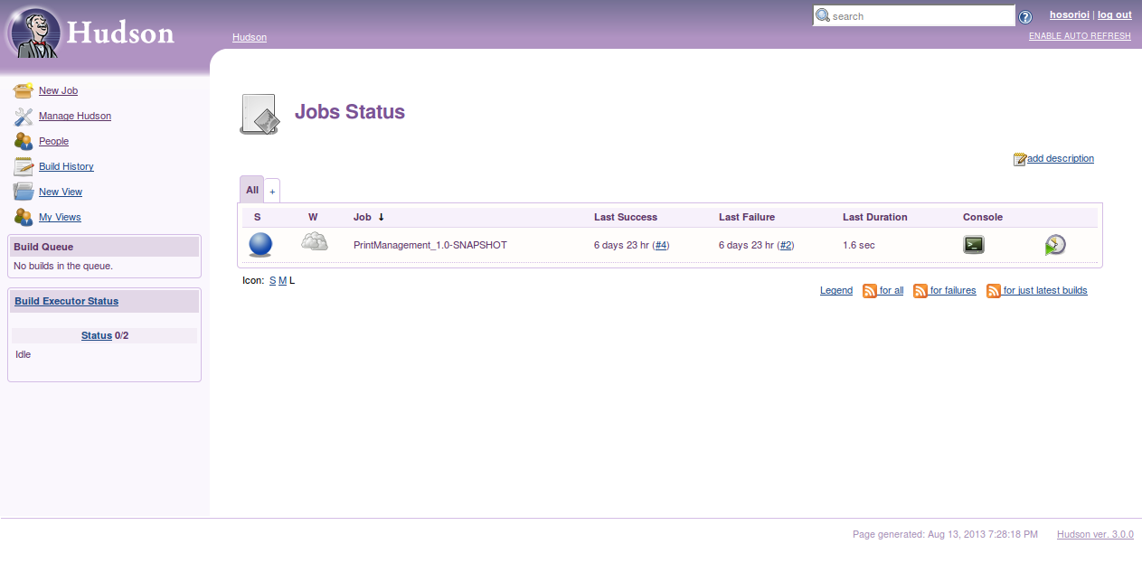
Managing Hudson Plugins

Select “Manage Hudson > Manage Plugin” from the menu. The screen below will be displayed.
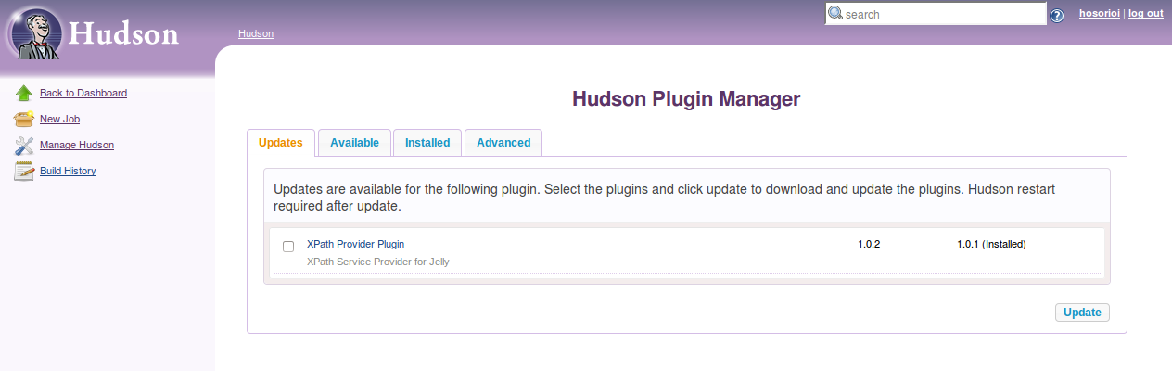

Select and download the following plug-ins to be available in Hudson.
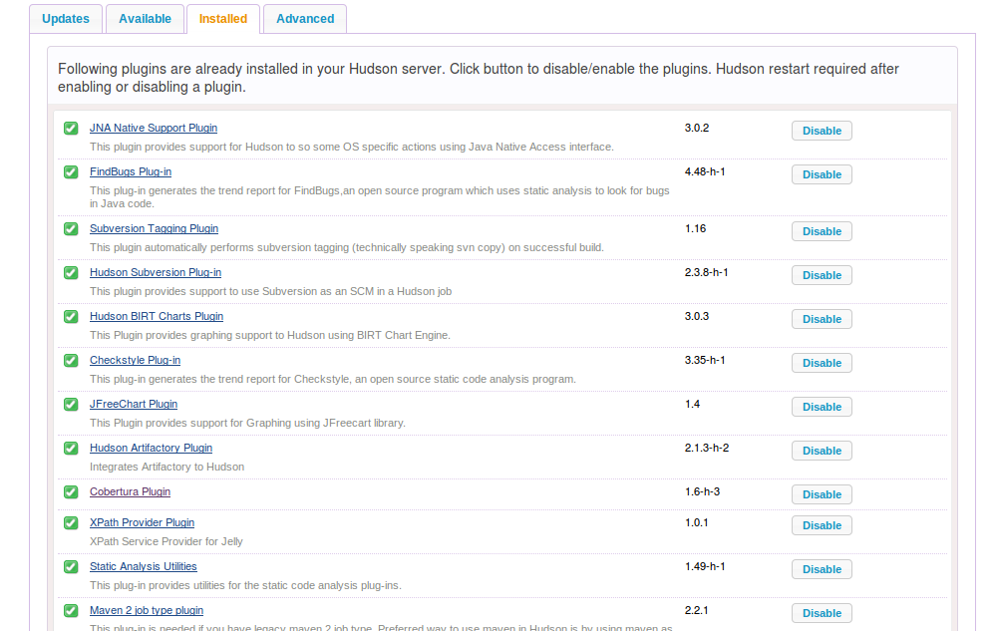
Creating a new Hudson Job
While inside Hudson Select “New Job”
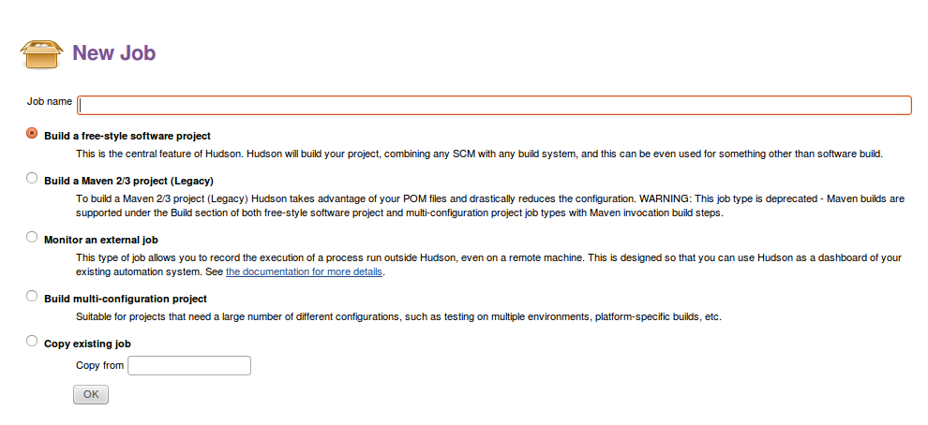
Enter entries to the following sections:
- Source Code management
  - Enter the Repository UL
  - and select a checkout strategy
- Build Environment
- Artifactory Configuration
  - Specify the Artifactory server URL
  - Select the target repository

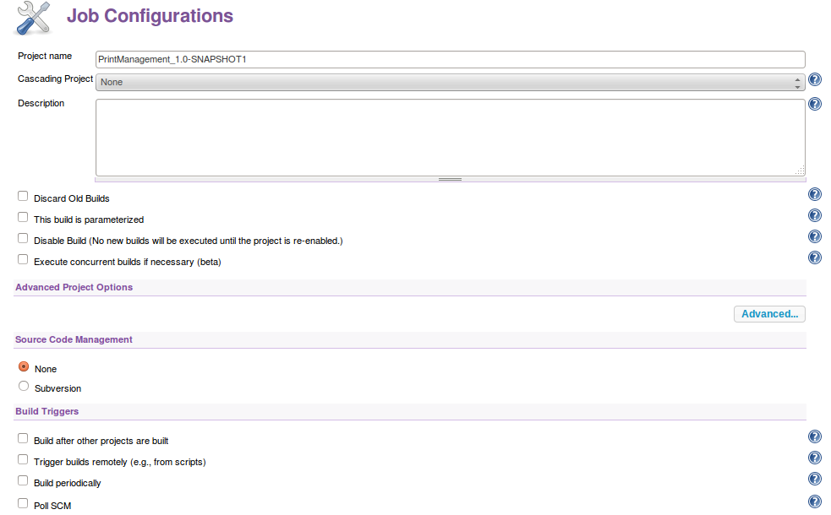
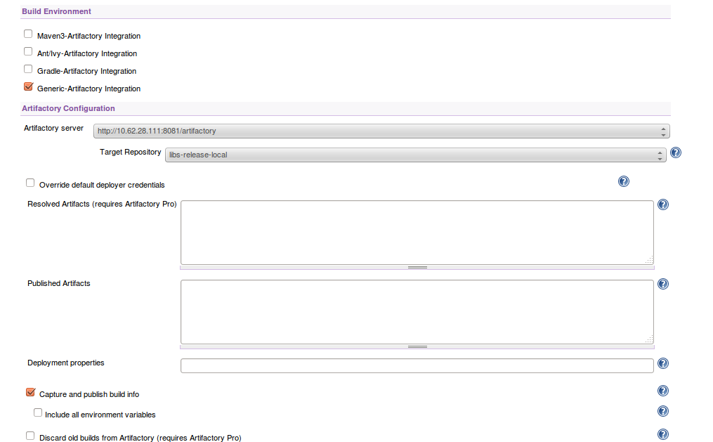

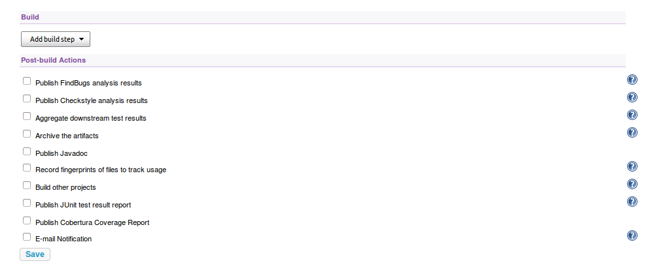
After completing all necessary fields press Save, and try building your new job by pressing Build Now in the menu.

